- Assumptions and Justifications

Assumption 1: No actions are taken to prevent the spread of the pandemic. Everything is executed naturally.
Justification: By doing so, we are eliminating the problem to calculate all of the possible factors that may happen during the prevention of the disease so that the model can be less complicated and easier to understand. In addition, the need that everything is to be “natural” means that there won’t be any unpredictable factor in the model, increasing the accuracy. By making this assumption, our model can both be rid of superfluous challenges and also be more precise.

Assumptions 2: There will be no mutation of the disease.
Justifications: Making this assumption can, again, make the model rid of the factors that are purely random and impossible to predict. If we did not make this assumption, our model would be entirely messy and hard to decipher, and the results would be wrong, since the time and kind of a disease mutation cannot be recorded like plain statistics.

- Variables

Here are the variables used in the model:
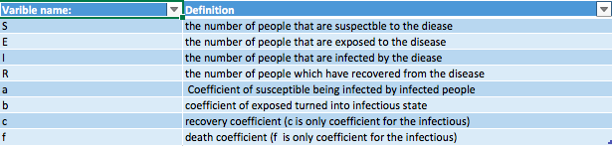

- SEIR Model

The model consists of 4 parts, the people who are Susceptible, Infected, Recovered, and Exposed (and all of the people). The 4 parts have the equations below as equations. With the equations, we can create the line graph below.
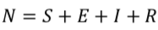
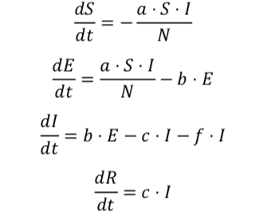
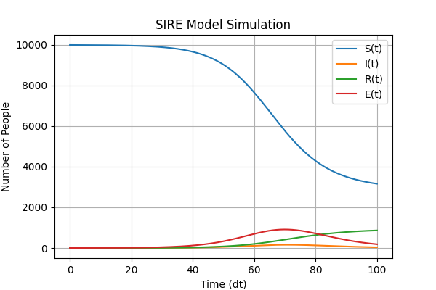

Also, we can use the diagram to describe the model.
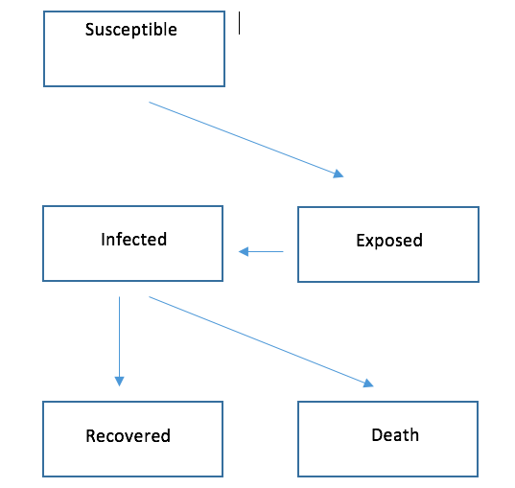
- Sensitivity Analysis

- We have tested the model by changing initial infection from 1 to 1000.
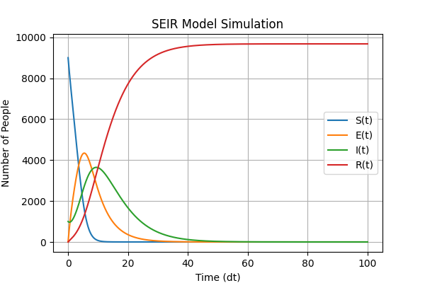
- We have changed A form 2 to 10.
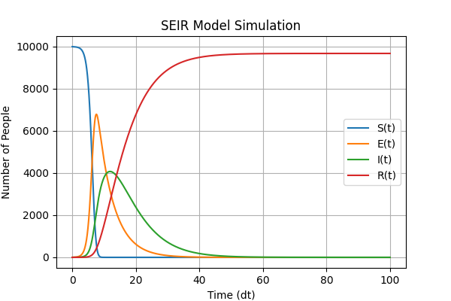
The model seems to have changed very much.

- Strengths and Weakness
Strengths:

1. Our model successfully identifies the many variables and factors in this situation, allowing our model to become all the more expressive and inclusive. Many pieces of information can be conveyed through our model, and it is both accurate and precise, which can help both us and the people get the statistics we need quickly.
2. The assumptions we made also cleared up a lot of troubles and problems which cannot be calculated precisely at the given time since it is almost impossible to keep track of the health condition of each person at every second. Therefore, by stating that no actions are taken to prevent the pandemic, we can eliminate the challenge of calculating all of the factors and levels of medical technology during its potential attempt at trying to prevent the pandemic. In addition, our second assumption that there are no mutations of the disease can also furthermore delete the unpredictable factors of the situation.

Weakness:
1. In our model, we only categorized the total people into 4 different groups: susceptible to the disease, exposed turning into infectious, recovered, and dead. However, in real life, it is undeniable that there are much more groups than those four, so this means that our model has not taken into account most of the groups, if not all of them, which might reduce the amount of information shown, but does not affect the accuracy.
2. Our second weakness is that our model only included a number of 10,000 people for the total number of people. Although the number is big enough, it may not be enough for the data that we are showing and may affect the percisement and the style in which the numbers are shown to some degree. However, overall, it does not provide a huge impact to the final result.

